Name : GADDE TEJA SAI
Roll No: AP25110070720
Subject : Data structure
Assignment : Lab Task-1
GitHub Link : https://github.com/tejasaigadde

- Write a program in C to store elements in an array and print them.
CODE:
#include <stdio.h>

int main() {
int arr[5], i;

printf("Enter 5 elements:\n");
for(i = 0; i < 5; i++) {
scanf("%d", &arr[i]);
}

printf("Array elements are:\n");
for(i = 0; i < 5; i++) {
printf("%d ", arr[i]);
}

return 0;
}
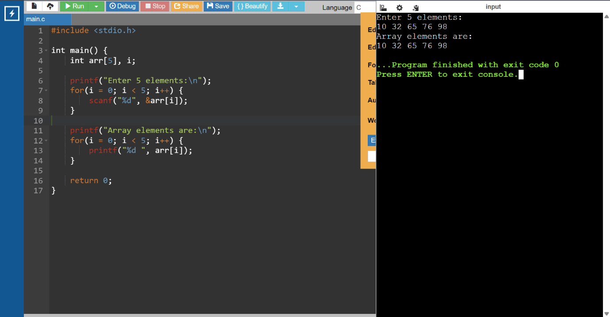

2. Wite a program in C to read n number of values in an array and display
them in reverse order.
CODE:
#include <stdio.h>

int main() {
int arr[100], n, i;

printf("Enter number of elements: ");
scanf("%d", &n);

printf("Enter elements:\n");
for(i = 0; i < n; i++) {
scanf("%d", &arr[i]);
}

printf("Reverse order:\n");
for(i = n - 1; i >= 0; i--) {
printf("%d ", arr[i]);
}

return 0;
}

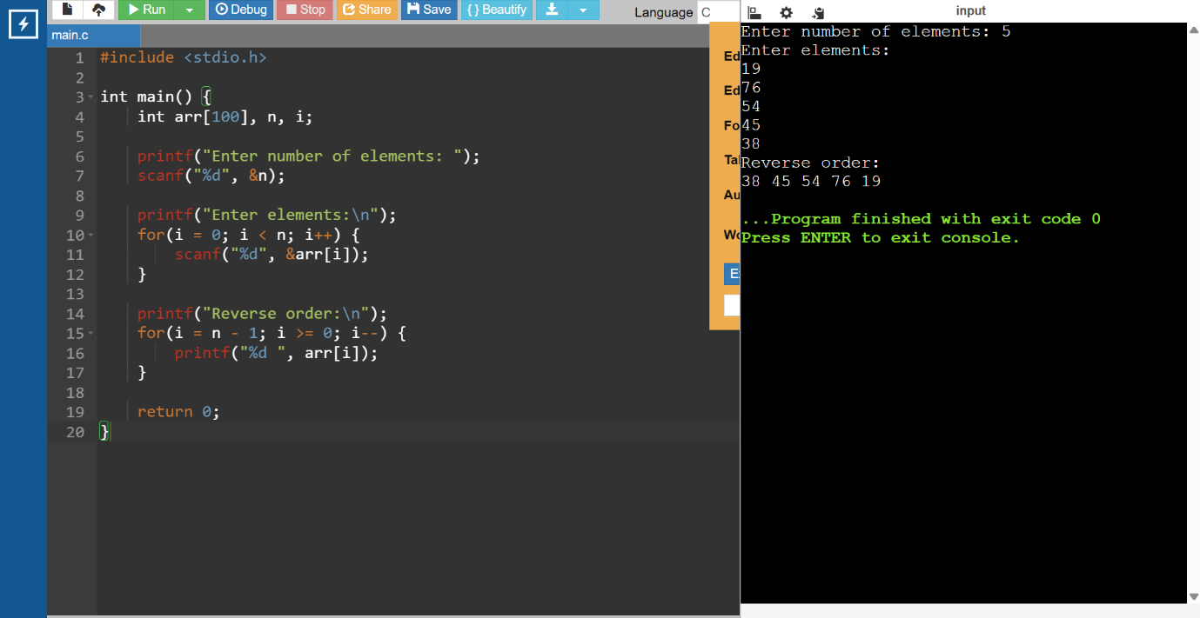

- Write a program in C to find the sum of all elements of the array.
CODE:
#include <stdio.h>

int main() {
int arr[100], n, i, sum = 0;

printf("Enter number of elements: ");
scanf("%d", &n);

printf("Enter elements:\n");
for(i = 0; i < n; i++) {
scanf("%d", &arr[i]);
sum += arr[i];
}

printf("Sum = %d", sum);

return 0;
}
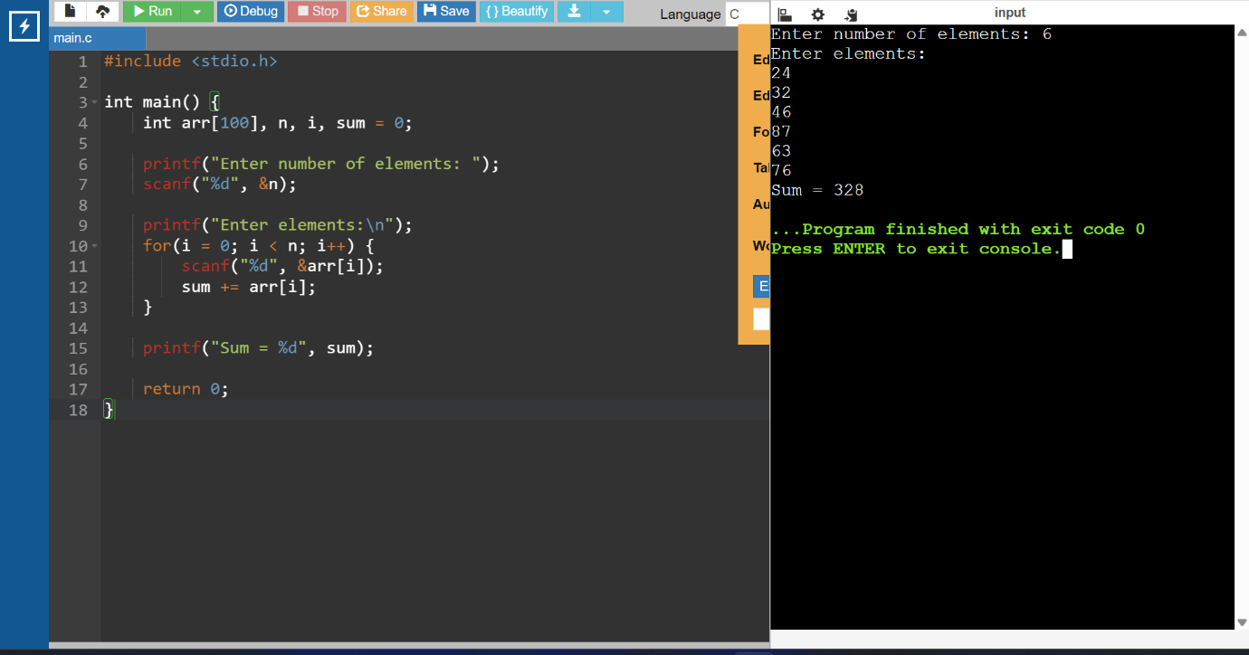
- Write a program in C to count the total number of duplicate elements in an array.
CODE:
#include <stdio.h>

int main() {
int arr[100], n, i, j, count = 0;

printf("Enter number of elements: ");
scanf("%d", &n);

printf("Enter elements:\n");
for(i = 0; i < n; i++) {
scanf("%d", &arr[i]);
}

for(i = 0; i < n; i++) {
for(j = i + 1; j < n; j++) {
if(arr[i] == arr[j]) {
count++;
break;
}
}
}

printf("Total duplicate elements = %d", count);

return 0;
}
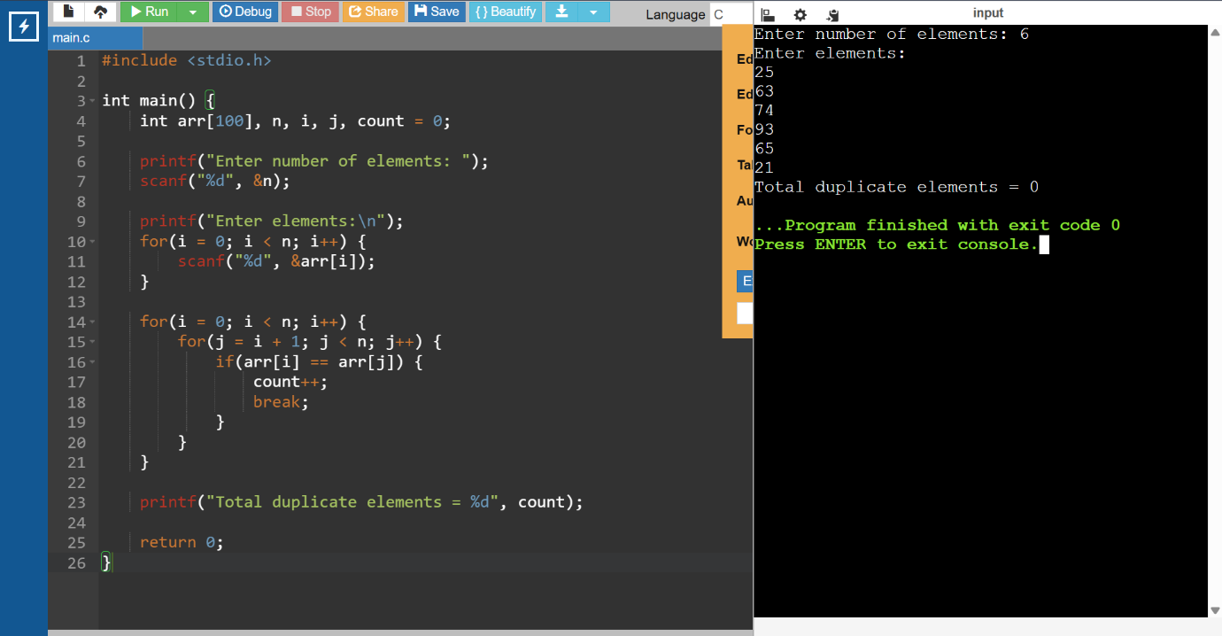

- Write a program in C to print all unique elements in an array.
CODE:
#include <stdio.h>

int main() {
int arr[100], n, i, j, flag;

printf("Enter number of elements: ");
scanf("%d", &n);

printf("Enter elements:\n");
for(i = 0; i < n; i++) {
scanf("%d", &arr[i]);
}

printf("Unique elements:\n");
for(i = 0; i < n; i++) {
flag = 1;
for(j = 0; j < n; j++) {
if(i != j && arr[i] == arr[j]) {
flag = 0;
break;
}
}
if(flag)
printf("%d ", arr[i]);
}

return 0;
}
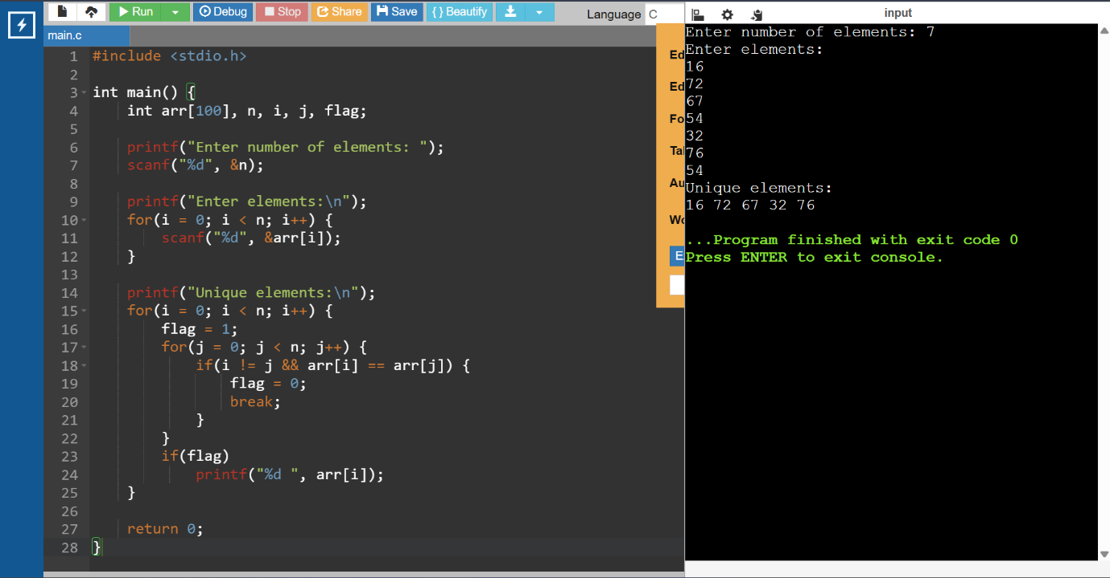

- Write a program in C to insert an element into an array at a specified position.
CODE:
#include <stdio.h>

int main() {
int arr[100], n, i, pos, val;

printf("Enter number of elements: ");
scanf("%d", &n);

printf("Enter elements:\n");
for(i = 0; i < n; i++) {
scanf("%d", &arr[i]);
}

printf("Enter position: ");
scanf("%d", &pos);

printf("Enter value: ");
scanf("%d", &val);

for(i = n; i >= pos; i--) {
arr[i] = arr[i - 1];
}
arr[pos - 1] = val;
n++;

printf("Array after insertion:\n");
for(i = 0; i < n; i++) {
printf("%d ", arr[i]);
}

return 0;
}
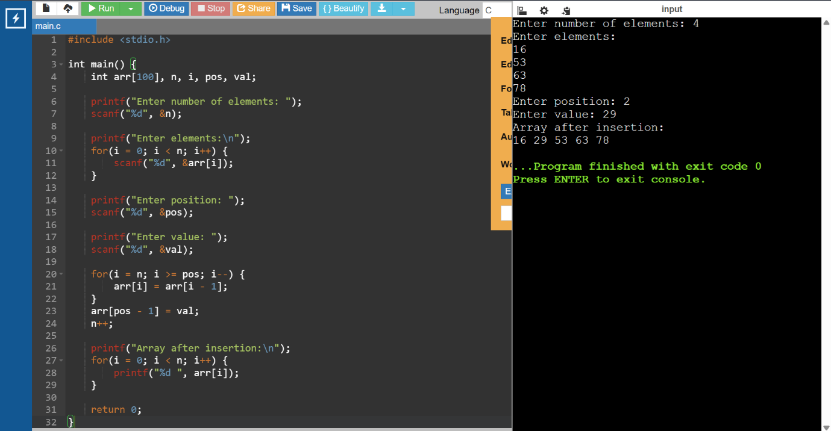

- Write a program in C to delete the element at the given index.
CODE:
#include <stdio.h>

int main() {
int arr[100], n, i, pos;

printf("Enter number of elements: ");
scanf("%d", &n);

printf("Enter elements:\n");
for(i = 0; i < n; i++) {
scanf("%d", &arr[i]);
}

printf("Enter position to delete: ");
scanf("%d", &pos);

for(i = pos - 1; i < n - 1; i++) {
arr[i] = arr[i + 1];
}
n--;

printf("Array after deletion:\n");
for(i = 0; i < n; i++) {
printf("%d ", arr[i]);
}

return 0;
}
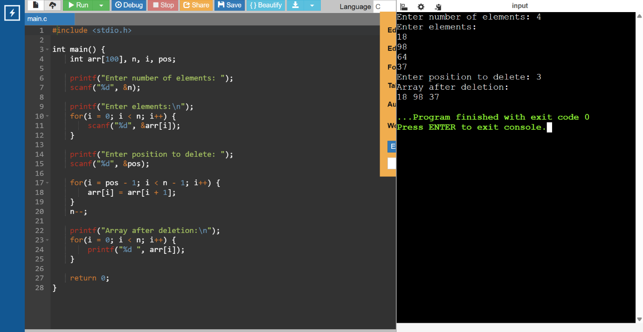

- Write a program in C to merge two arrays into a single array.
CODE:
#include <stdio.h>

int main() {
int arr1[50], arr2[50], arr3[100];
int n1, n2, i;

printf("Enter size of first array: ");
scanf("%d", &n1);

printf("Enter elements of first array:\n");
for(i = 0; i < n1; i++) {
scanf("%d", &arr1[i]);
arr3[i] = arr1[i];
}

printf("Enter size of second array: ");
scanf("%d", &n2);

printf("Enter elements of second array:\n");
for(i = 0; i < n2; i++) {
scanf("%d", &arr2[i]);
arr3[n1 + i] = arr2[i];
}

printf("Merged array:\n");
for(i = 0; i < n1 + n2; i++) {
printf("%d ", arr3[i]);
}

return 0;
}
